Virgin Islands Bulletin: November 3, 2012
Veterans Day 5K/V.I. Cross-Country Championships…Winners…
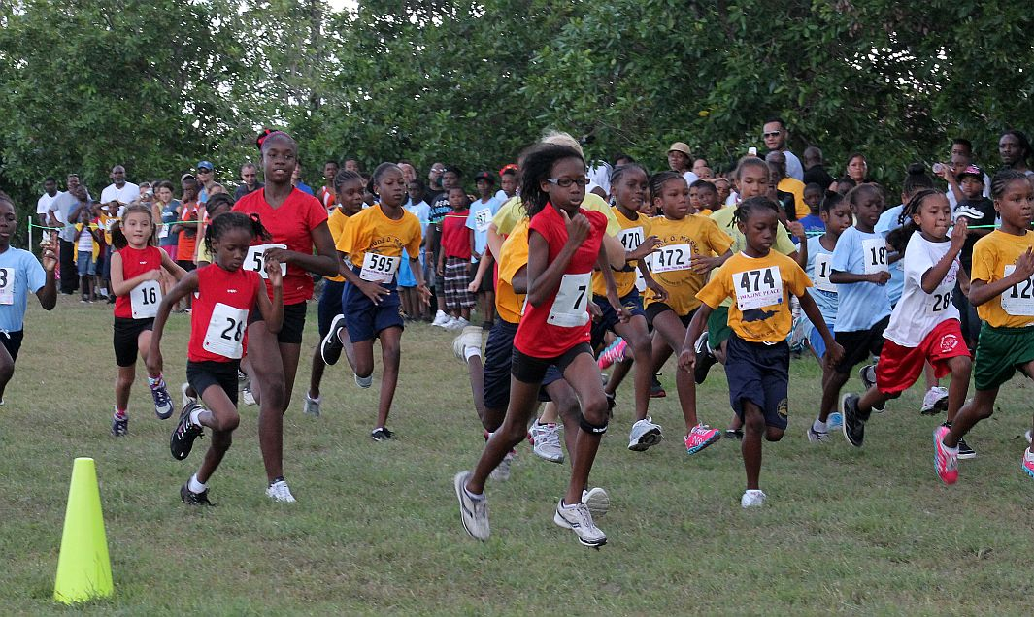
Start! 2012 V.I. Cross-Country Championships Girls Under 14 St. Croix Track Club Photo
The 2012 Virgin Islands Cross-Country Championships/Veterans Day 5K was held at the University of the Virgin Islands St. Croix campus on Saturday morning. Highlights of the day included races for divisional titles
Girls Under 14
Mikeala Smith of Good Shepard School/St. Croix Track Club continued her winning ways and as she won going away with a time of 6:40 for the 1 mile race; Avia Joseph of Claude O. Markoe school was second in 7:11 and Nabria Ritter of Claude O. Markoe School was third in 7:14.
Boy Under 14
This was the most competitive race of the day.. In the boys under 14 1mile the top V.I. runners went head-to-head. Ja-Coy Blaise of the Cheetahs Track Club/Gladys Abraham School in St. Thomas took the lead in the race around the half-mile mark and was pursued by a group of St. Croix runners who went at it in the 4H-V.I.Pace Runners Cross-Country Series where they shared the top spot; they include Phar-I-Merchant and Valence Modeste Ricardo Richards School and Shaimark Spencer of Alfredo Andrew School. For the remaining half of the race these runners were in a close contest for the championship title. In the end Modeste edged to the lead and held it with lest than 75 meters to go in the race to take first place with a time of 6 min 6 seconds. Blaise was second in 6:11 and Spencer was third in 6:15.
Girls Under 10
Tyannah Lake of Alexander Henderson School took first in 7:09; it was a close race for second with Michelle Smith of Good Shepard School/St. Croix Track Club was second in 7:54 and Aria Moses of Good Shepard School was third in 7:56
Boys Under 10
Masse Hatcher of Good Hope School took the top spot in 7:18; James Beck of Freewill Baptist School was second in 7:27 and Stephen Nelson of Freewill was third in 7:32
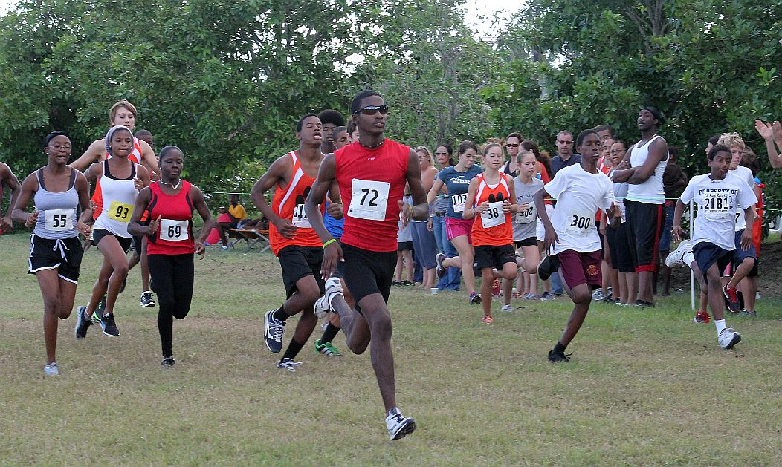
Start! Boys and Girls under 16 2 mile St. Croix Track Club Photo
Boys Under 16
The top runners in the V.I. in this age group and members of one of the youngest V.I. CARIFTA Junior teams were at the start line including Malique Smith St. Croix Educational Complex High School/St. Croix Track Club who led from the start and set a 2 mile course record in 10:50; Ateniah Roacher Ivana Edurora Kean High School/Cheetahs Track Club finished second in 11:10; Rodney Griffin Educational Complex High School/St. Croix Track Club was third in 11:47. Evan Jones, youngest of the first four of St. John was fourth in 12:01.
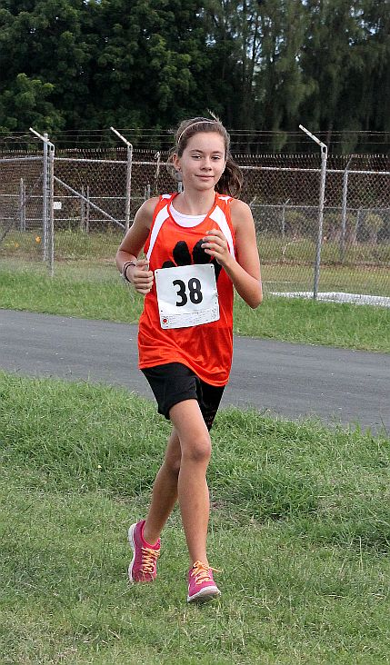
Rachel Conhoff St. Croix Track Club Photo
Girls Under 16
Rachel Conhoff of Country Day School took top honors in the 2 mile with a time of 15:17; Nia Jack of St. Croix Educational Complex High School/Hounds and Foxes Track was second in 16:21 and Krystal Gordon of John H. Woodson School/St. Croix Track Club was third in 16:26
Boys Under 20
Freddie Gomez of Freewill Baptist School took first place in the 3.1 mile race with a time of 21:38; Lais Williams Country Day School was second in 21:50; Akelem Romain of Freewill Baptist was third in 22:23; John Macaluso Country Day School was third in 24:10

Girls Under 20
Keshema Fleming of Ivanna Eudora High School took first place in the 3.1 mile race with a time of 21:38; Jazmine Willock of St. Croix Country Day School was second in 21:50 and Karen Dascent of St. Croix Educational Complex High School/St. Croix Track Club was third in 27:24
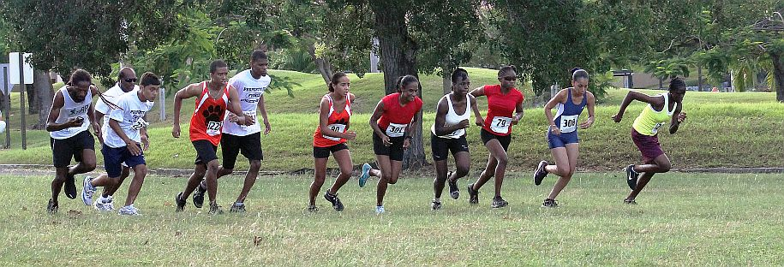
Start! Open/Under 20 5K St. Croix Track Club Photo
Open Male 5K (3.1 miles)
Shane Deganes of The St. Thomas Association of Road Runners was the top finisher in the race with a time of 17:46, the fastest time run on the course this year. Bobby Mohammad finished second on 22:14.
Open Female 5K (3.1 miles)
Mireille Smith of the St. Croix Track Club won the open division with a time of 23:02.
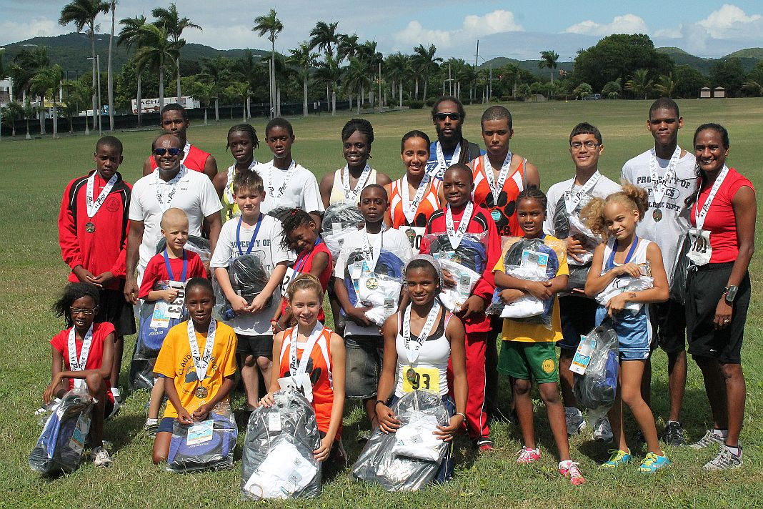
2012 V.I. Cross-Country Champions St. Croix Track Club Photo
Notes:
1] Cross-country runners male and female and all ages are invited to compete in the V.I. National Cross-Country Championships to be held on November 3 at UVI St. Croix. The competition included: Under 10 1 mile boys and girls; Under 14 Boys and Girls 1 mile; Under 16 Boys and Girls 2 miles; Open and Under 20 Male and Female 5K (3.1 miles) Qualifiers in the national championships may be selected to compete in the NACAC Cross-Country Championships in Kingston, Jamaica.
2] Some of the youngsters in the V.I. Cross-Country Championships competed on the V.I. CARIFTA Jr. Team for 2012 they include: Malique Smith St. Croix Track Club, Atiniah Roacher Cheetahs Track Club; Nia Jack Hounds & Foxes Track Club; Britney Sage St. Croix Track Club. It was one of the youngest V.I. CARIFTA teams ever.
3]] Complete results will be posted on: www.eteamz.com/stxtc (St. Croix Track Club) and http://virginislandspace.org (The Virgin Islands Pace Runners)

4] The 4-H/V.I.Pace Runners Cross-Country Series is hosted by the University of the Virgin Islands Cooperative Extension Service/4H Program; organized by the Virgin Islands Pace Runners and sanctioned by the Virgin Islands Track and Field Federation.

5]] For information contact: The St. Croix Track Club Keith Smith 340-778-3026 wk, 340-277-1123 c keithsmith@gmail.com or The Virgin Islands Pace Runners 340-643-2557 wallacewilliams@msn.com

