The Official Virgin Islands
35th ANNIVERSARY
VIRGIN ISLANDS PACE RUNNERS CALENDAR
2014-2015
UPDATED June 29, 2014
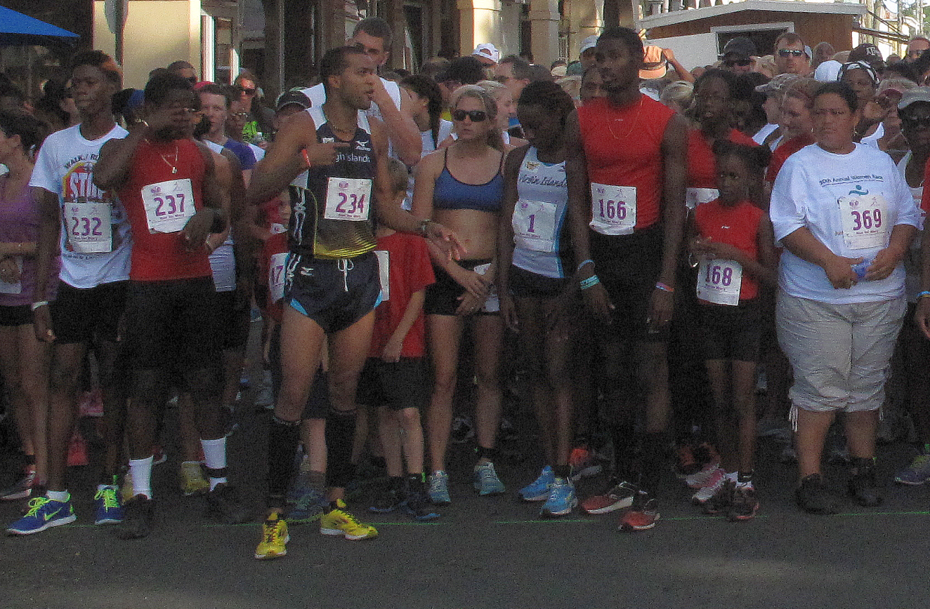
August
30/08/14 It’s On…The Street Meet—60m, 100m, 200m, 400m, 800m—St. Croix
September
@1/09/14 The Labor Day 5K Road Race—St. Croix 3.1 Miles
@14/09/14 The Virgin Islands 10K—St. Croix 6.2 Miles
TBA The Sunset Relay--St. Thomas 3 Person Teams
October
TBA UVI Upward Bound 2Mile Run/Walk--St. Croix UVI
04/10/14 CoastWeeks Beach Relay--St.Croix 2 x 2miles
01/10/14 4-H/V.I.Pace Runners Cross-Country Series--St. Croix UVI
08/10/14 4-H/V.I.Pace Runners Cross-Country Series--St. Croix UVI
18/10/14 The 29th Annual West Indies Lab 5 Miler--St.Croix 5 Miles
22/10/14 The 4-H/V.I.Pace Runners Cross-Country Series--St. Croix UVI
TBA IAA/HPR Cross-Country Series--St. Thomas UVI
TBA Cancer Awareness Walk/Run--St.Thomas 2Miles
November
09/10/14 Buck Island Ocean Swim--Buccaneer Hotel--St. Croix
@15/11/14 The 30th Veterans Day 5K--St.Croix 3.1 Miles
(V.I. Cross-Country Championship)
27/11/14 Manchester 5 Mile (STX Ed.)--St. Croix 5 Miles
TBA The Catholic Charities 5K Walk/Run--St. Thomas 3.1 Miles
TBA STAR 10K Fun Run St.Thomas UVI
December
06/12/14 The St.Croix Metric Mile—St.Croix 1500m
@1412/14 The 13th St.Croix International Marathon—26.2
@14/12/14 The 6th St.Croix Marathon Relay—6 runners—26.2 Miles
@14/12/14 40th The St.Croix International Half-Marathon--St. Croix 13.1 Miles
@20/12/14 The 31st Cane Bay 5Mile Road Race—St.Croix 5 Miles
TBA Kwanzaa 7K Run--St.Thomas 4.3Miles
January
04/01/15 The 28th Annual Children Race--St.Croix, Frederiksted, 800 Meters
@05/01/15 The 33RD Three Kings Mile--St.Croix, Frederiksted, St.Croix 1 Mile
TBA MLK Jr. 5K Walk/Run---St. Thomas 3.1Miles
18/01/15 The 30th Annual Martin Luther King Fort-To-Fort Run--St.Croix 15.5Miles
@25/01/15 The 6th St.Croix Scenic 50—St.Croix 50 Miles
The 33RD Annual Women's Jogger Jam Walk/Run--St.Thomas 2 Miles
February
14/02/15 The 29th Annual Toast-To-The Captain RR--St.Croix 8.4 Miles
TBA Magen's Bay/Peterborg 10k--St.Thomas 6.2 Miles
TBA Leave a Footprint Cruise Run--Frederiksted, St. Croix 5K
TBA NACAC Cross-Country Championships—TBA
21/02/15 St. John 8 Tuff Miles--St. John--8 Miles
March
1/03/14 The Flight #64 Four Mile--St.Croix 4 Miles
TBA Runners Choice 2Mile--4Mile--6Mile--St. Thomas
13/03/15 The 14th Queen Mary Highway/UVI--St.Croix, 3.1 Miles
TBA Black History Month Ultrasprint--St.Thomas .5Mile Youth, 1Mile Adult
April
18/04/15 The 33RD Annual National Library Week Run To Your Library--St.Croix 3.1M
TBA The Men's 2Mile--St. Thomas 2 Miles
May
01/05/15 The 27th Paradise 5K--St.Croix 3.1 Miles
30/04/15 The 16th Annual Children Run Christiansted--St.Croix 520 Meters
TBA Carnival Mile--St.Thomas 1 Mile
TBA Mothers Against Guns 2Mile Run--St. Thomas
25/05/15 The 32ND Annual Memorial Day 2 Mile Run--St.Croix 2 Miles
June
07/06/15 The 31ST Annual The Women Race--St.Croix 2 Miles
20/06/15 The 29th Annual Olympic Day Run—St.Croix 1 Mile
TBA The Annual Olympic Day Run--St. Thomas 1 Mile
July
No events scheduled
About this Calender
This schedule will be updated as information is finalized. V.I. Pace Runners Races and STAR Races (member organizations of the Virgin Islands Track and Field Federation) are sanctioned by the Virgin Islands Track & Field Federation. @=V.I. Track & Field Federation recognized national championship race. St. Croix events are conducted by V.I. Pace Runners (V.I.Pace runners)--St. Thomas events are conducted by the St.Thomas Association of Road Runners (STAR) or as noted. Both organizations assist local and visiting runners with their needs.
For The Virgin Islands Pace Runners Information call: 340-643-2557
http://virginislandspace.org
wallacewilliams@msn.com
For St.Thomas Association Race Information call: 340-775-6373
http://stthomasroadrunners.org/
therese10k@yahoo.com
Results 99-2000 | Results 2000-2001 | Results 2001-2002 | 2002-2003 Results | 2003-2004 Results
St.Croix Map

